RODALS SRL

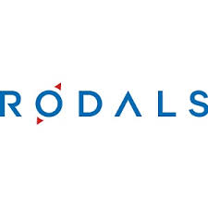

<https://rodals.md/>

CONACUL CONTESEI SRL



https://www.facebook.com/LaContessa2018/?locale=ro_RO

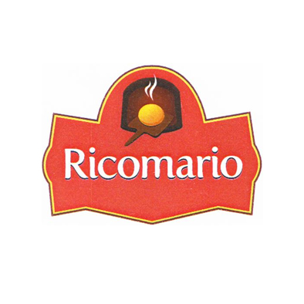

RICOMARIO SRL

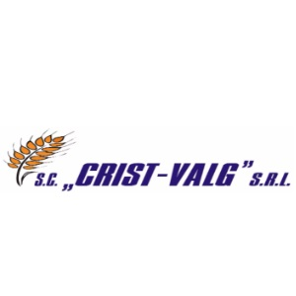

CRIST - VALG SRL

PRODUSE CU TRADITIE SRL



https://www.facebook.com/CuTraditii/

HEGEMON GRUP SRL



<https://www.brutaria-cuptoras.md/>

IUGINTERTRANS S.A.



<https://milina.md/ro/>

SAVIT-SIM SRL

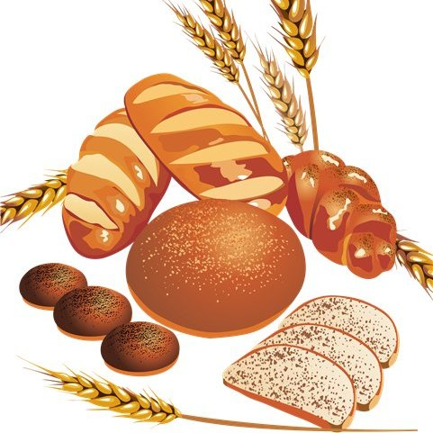

<https://www.facebook.com/savitsim1996>

MĂCINĂTORUL SRL

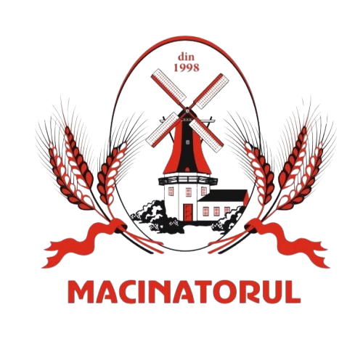

<https://macinatorul.com/>

ECO-GRAIN ELEVATOR SRL



<https://www.facebook.com/ecograinelevator>

BUDNEA RODICA Î.I.



<https://www.facebook.com/profile.php?id=100088436980271>

BRODEȚCHI SRL



<https://www.facebook.com/Brodetchi>

”GLINCOR - COM” S.R.L.



https://brutariaglincor.md/

Cahul Pan SRL



<https://cahulpan.com/>

Oleineac SRL



<https://oleineac.md/>

Aceștea de mai jos nu au nici logoo nici fb nici site respectiv puneți-le denumirile cu un Shirift mai deosebit.

AGROCERPROD SRL

PRICOP IGOR OLEG GȚ

FRANDALEX-AGRO SRL

SOLGON - I SRL

IUNALIS-AGRO SRL

RICONDUCT SRL

Generalchim SRL